

ASSIGNMENT TITLE

Filtering and Sorting

Submitted By : Sachin Yadav
Course : Data Analytics With AI – September batch Live
Institude : PW Skills
Date : 10 Dec. 25

Question 1: Show employees working in either the ‘IT’ or ‘HR’ departments.

SQL Query:
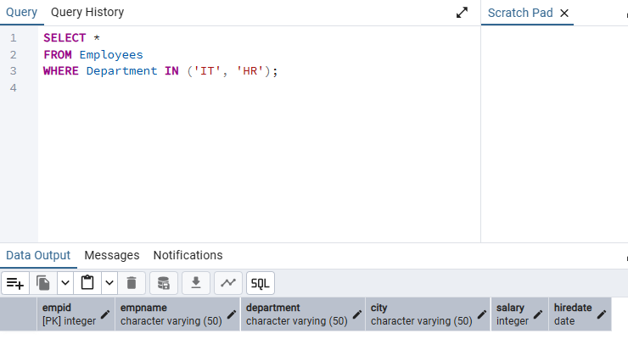

Explanation:
The IN operator checks whether the department is either IT or HR.
It returns all employees belonging to these two departments.

Question 2: Retrieve employees whose department is in ‘Sales’, ‘IT’, or ‘Finance’.

SQL Query:

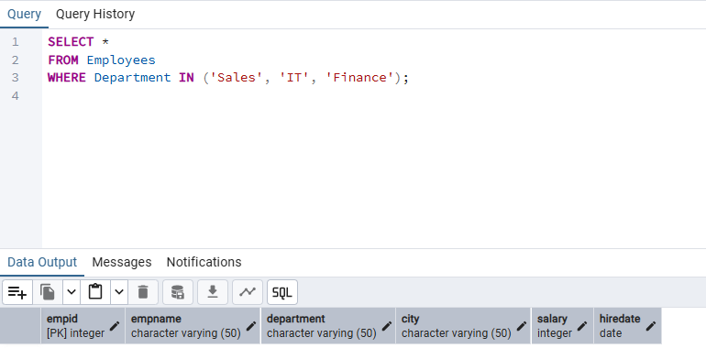

Explanation:
Multiple departments are filtered using IN for cleaner, readable syntax.

Question 3: Display employees whose salary is between ₹50,000 and ₹70,000.

SQL Query:

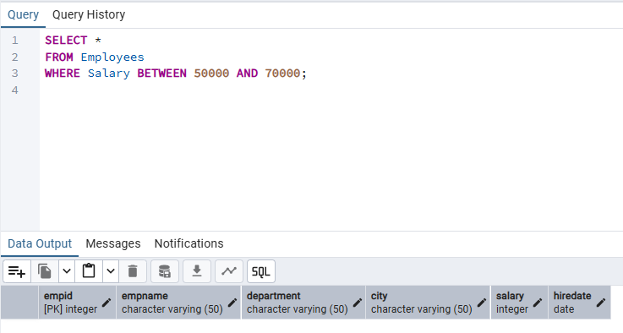

Explanation:
The BETWEEN operator is inclusive of both boundary values.

Question 4: List employees whose names start with the letter ‘A’.

SQL Query:

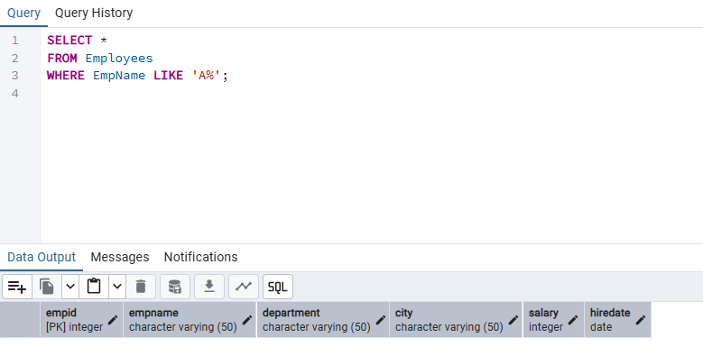

Explanation:
A% matches names beginning with A (example: Aman, Arjun, Anjali).

Question 5: Find employees whose names contain the substring ‘an’.

SQL Query:
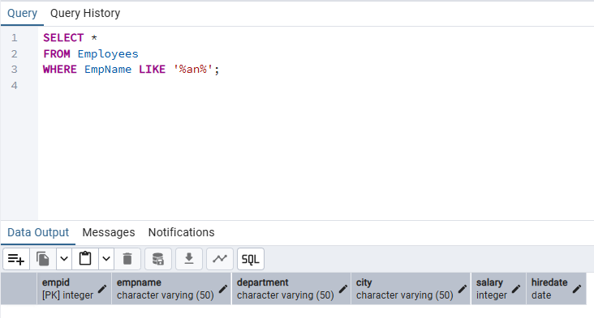

Explanation:
%an% matches any name that has "an" anywhere (Aman, Karan, Anjali).

Question 6: Show employees who are from ‘Delhi’ or ‘Mumbai’ and earn more than ₹55,000.

SQL Query:
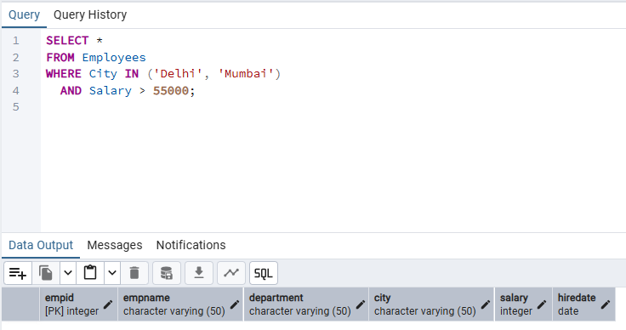

Explanation:
Two filters are applied: (1) City must be Delhi or Mumbai; (2) Salary > 55,000.

Question 7: Display all employees except those from the ‘HR’ department.

SQL Query:
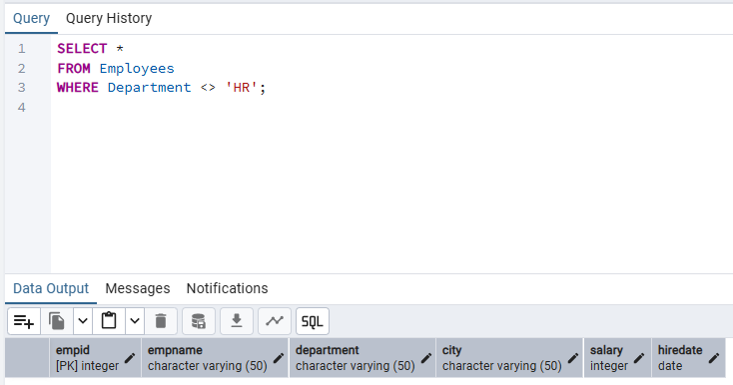

Explanation:
The <> operator excludes HR employees.

Question 8: Get all employees hired between 2019 and 2022, ordered by HireDate (oldest first).

SQL Query:
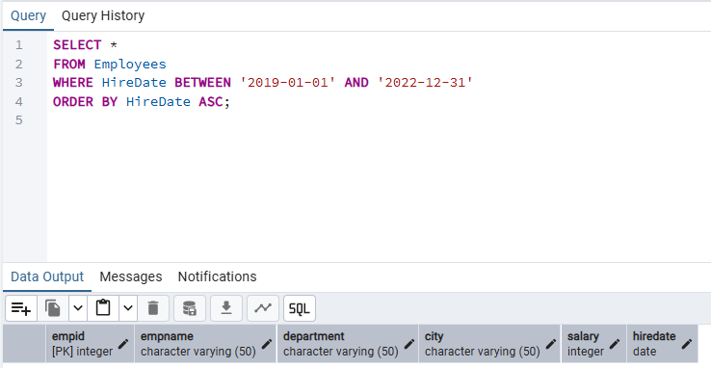

Explanation:
- BETWEEN is inclusive of both years.
- ORDER BY ASC shows the oldest employees first.

